Why Steam·Z can be reduced Steam loss ?
There is an enormous difference in specific volume between steam and condensate.
The volume increases by 1,600 times when water transforms into steam at an atmospheric pressure.
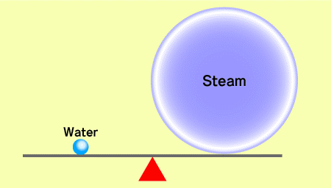
Let's take an example of an orifice with an inlet pressure of 0.1 Mpa.G.
The specific volumes at 0.1 Mpa.G are:
The volume of steam is approximately 850 times that of condensate.
Steam ： 0.9018 /kg
Condensate ： 0.00106 /kg
The volume of steam is approximately 850 times that of condensate.
Therefore, if the flow speed of steam were 850 times faster, the flow rate would be the same for steam and condensate. However, the flow speed of steam is only 32 times that of condensate. So, the flow rate of steam is only 3.7 % of the flow rate of condensate.
32 / 850 × 100 ＝ 3.7 ％
This figure is confirmed by the calculation formula and laboratory tests.
Steam flows more than 30 times faster than condensate.
Normally,
Flow speed of steam : 30 - 40 m/sec
Flow speed of condensate : 1 - 1.5 m/sec
Please imagine a typhoon on the coast with a wind of more than 30 m/sec.
The friction between the wind and the surface of the sea produces waves, which go beyond the break water.
In much the same way, when steam and condensate flow together, waves are produced upstream of the orifice, and these waves seal the orifice, preventing steam to pass through. As a result, even when the condensate load diminishes, there is almost no steam leakage.
Here are the images of this phenomenon with different condensate loads.
- When the condensate load is 100 %
When the condensate occupies the full section of the pipe. Obviously, there is no steam leakage.
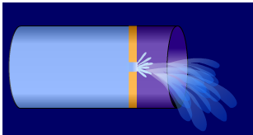
http://www.steam-z.com/english/100.html
2. When the condensate load is 50 %
The condensate occupies half of the pipe. If condensate and steam were to flow at the same speed, there would be no friction between the condensate and the steam. So, there would always be steam leakage through the orifice. (A)

As the steam flows more than 30 times faster than the condensate, the speed differential between the steam and the condensate produces waves, and these waves seal the orifice at more than 99 % of the time, allowing almost no steam to go through. (B)

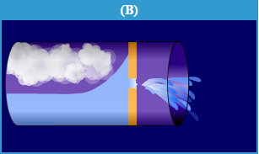
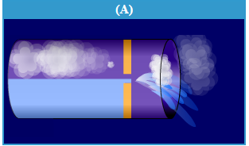

However, in reality, the things are NOT like (A).
http://www.steam-z.com/english/50.html

3. When the condensate load is lower than 50 %
The condensate waves do not any more occupy the orifice all the time, which allows the steam to go through at times. When the steam has gone through, the waves come back to seal the orifice again.
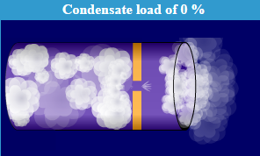
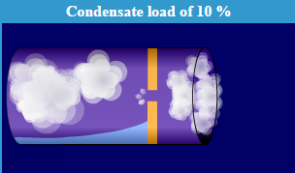
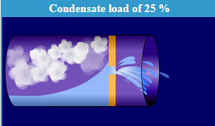

http://www.steam-z.com/english/10.html

In other words, as the condensate load diminishes, the time at which the condensate waves seal the orifice diminishes.
When condensate diminishes, steam pressure diminishes as well.
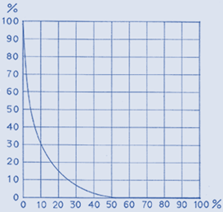
With steam pipes, the quantity of condensate changes depending upon the outside temperature, while the steam pressure remains constant. However, with most heat exchangers, when the condensate flow rate changes, the steam pressure changes as well.
The condensate flow rate diminishes when the heat requirement is smaller, and when the heat requirement is smaller, the steam valve is closed, manually or automatically, to reduce the steam flow, resulting in a lower steam pressure in the heat exchanger..
As the pressure downstream remains constant, the differential pressure becomes smaller, and the evacuation capacity of the orifice becomes smaller as well.
In other words, even when the condensate flow rate diminishes, the condensate load is relation to the capacity of the orifices does not change much. In practice, with normal heat exchangers, even when the condensate flow rate diminishes, the steam leakage does not increase.
This chart show the relation between the condensate load and the steam flow rate (leakage)

Condensate load and
Steam flow rate
(leakage)

Steam flow rate
(leakage)

Condensate load
The horizontal axis is the condensate load, and the vertical axis is the steam flow rate (leakage).
For instance, Steam Z Model Z-10 has a capacity to evacuate 172 kg/hr of condensate with a differential pressure of 0.5 Mpa, and 172 kg/hr corresponds to 100 % of the horizontal axis.
If there is no condensate and if there is only steam going through the same orifice, its flow rate is 8 kg/hr, and this corresponds to 100% of the vertical axis.
As long as the condensate load is above 50%, steam leakage can be considered to be zero..
When the condensate load goes below 50 %, there begins to be steam leakage.
With a condensate load of 25 %, the steam leakage is about 10 %. This means that the steam leakage is 0.8 kg/hr (8 Kg/hr × 10 % = 0.8 kg/hr)
This is only 0.47 % of the capacity of the orifice (172 kg/h）.
With a condensate load of 10 %, the steam leakage is approximately 30 %, which is 2.4 kg/hr (8 kg/hr × 30 % = 2.4 kg/hr) This is only 1.4 % of the capacity of the orifice.
This means that even with a condensate load of 10 %, the steam leakage of Steam Z is smaller than the quantity of steam that escapes together with condensate when a conventional steam trap is working normally.
（NB） This graphic shows the relation between the condensate load and the steam leakage at a constant pressure.
With the exception of steam transport pipes, the pressure of which is always constant, with most heat exchangers, when the condensate flow rate diminishes, the need for heating is low and the steam pressure, regulated with an automatic valve, is also low. When this happens, the differential pressure diminishes, and steam leakage diminishes.
Therefore, with normal continuous processes, there is no problem of steam leakage, even when the condensate flow rate diminishes.

