Superior Water treatment technology

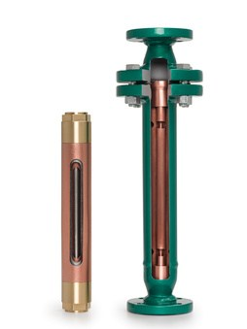
There is much more to effectively controlling scale and corrosion than simply applying a magnetic field to a water source. Superior follows a precise formula based on water flow rate and pipe diameter ensures that the correct model of Superior Water Conditioner is selected for the designed flow rate of the application, producing optimum results consistently.
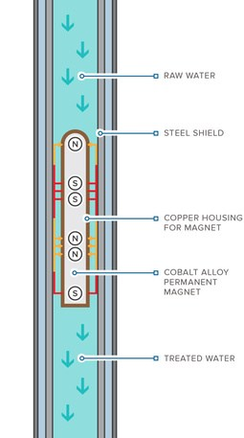
Magnetic Treatment of Water
The Superior Water Conditioner controls scale and corrosion without the use of chemicals.
When water is subjected to temperature change (delta T), pressure change (delta P), friction, turbulence and/or evaporation, dissolved minerals, primarily calcium carbonate (CaCO₃) and magnesium carbonate (MgCO₃), will precipitate out of solution and deposit on the heat transfer surfaces of plumbing systems and equipment in the form of a rock-like build-up, commonly called lime/scale. At the molecular level, the negatively and positively charged ions of these minerals are attracted to, and bond tightly together with, one another, thus forming the lime/scale deposit known as calcite. These mineral deposits are a great insulator and require much more energy to heat or cool water in many different types of residential, commercial, institutional and industrial applications.
As water passes through the Superior Water Conditioner’s treatment chamber, it is subjected to a series of alternating, reversing-polarity, permanent magnetic fields, which interrupts the natural scale-forming characteristics of CaCO₃ and MgCO₃
How Superior Water Conditioners work

by temporarily altering their ionic charge identity. Instead of being attracted to one another, the molecules are caused to act like ions of similar charges and repel one another as they precipitate out of solution. This causes the minerals to precipitate out of solution in a physical state of suspension known as aragonite (an amorphous mud-like or powdery form), rather than the hard rock-like calcite. This aragonite will flow right on through a plumbing system or drop to a low area within equipment so that it can be easily blown down or bled off. It can also be removed by other physical means such as centrifugal separation and filtration equipment. Since chemicals are unnecessary with the application of the Superior Water Conditioner, the purity of the water is not affected in any way, and it can be safely and legally discharged to a sanitary sewer or even to the environment, where allowed.

The presence of aragonite in the water provides an additional benefit in terms of corrosion protection. A thin film of the soft aragonite will adhere to all wetted surfaces of the plumbing system and equipment, keeping free oxygen and other corrosive properties in the water from reaching and attacking the metallic components, thus assisting in corrosion control.
A research project sponsored by ASHRAE clearly demonstrates the benefits and efficiency of physical water treatment in controlling calcium scale accumulation in circulating, open-loop cooling water systems, and showed an 8% reduction in the water’s surface tension. The report also concluded that best results were obtained when alternating, reversing-polarity, permanent magnetic fields were used in the circulating line of the cooling tower and that mineral fouling can be substantially reduced in heat transfer equipment (chiller/condenser) applications, with significant energy and water savings.

Advantages

There are four major concerns for all users of water with the purpose of thermal transfer:
- Cost-Effective Water treatment
- Energy Savings
- Water Conservation
- Pollution prevention

The Superior Water Conditioner® meets all four of these concerns for effective water treatment through control of lime/scale for thermal transfer efficiency.

Non-chemical water treatment can reduce possible costs associated with chemical water treatment:
- Transportation, storage, installation and disposal
- Maintenance and energy for chemical feed pumps
- Maintenance for conductivity meter and solenoid valve
- Water testing materials and labor
- Heat transfer loss due to scale
- Corrosion of equipment
- Acidizing
- Bleeding water to control TDS

Using magnetic water treatment reduces pollution, health risks and equipment damage by eliminating the need for acidizing steam boilers and chillers to remove excessive scale that can remain despite chemical treatment.
Blow-down of the boilers and bleed-off for cooling towers can be reduced considerably after installing a properly sized and designed magnetic water conditioner. However, it may be helpful to maintain the same blow-down as before until all the scale is removed if the boiler or chiller is badly scaled at the time of installation.

Superior Water Conditioner’s® numerous benefits and absence of ill side effects merit consideration of these products. The Superior Water Conditioner® system has proven time and time again that it will pay for itself by the elimination of chemical costs alone. Payback is accelerated when all of the aforementioned costs are factored into the analysis!

APPLICATION | USAGE | *AVERAGE PAYBACK
Boiler | Process Steam | 6 – 9 months
Boiler | Process hot water | 8 – 12 months
Boiler | Steam heating | 15 – 18 months
Boiler | Hot water heating | 24 – 36 months
Cooling tower | Process | 10 – 12 months

*This payback varies considerably due to the quality of the water, once-through or returned-as-condensate recirculating systems, as well as the effectiveness and cost of the previous chemical treatment.

